Code:

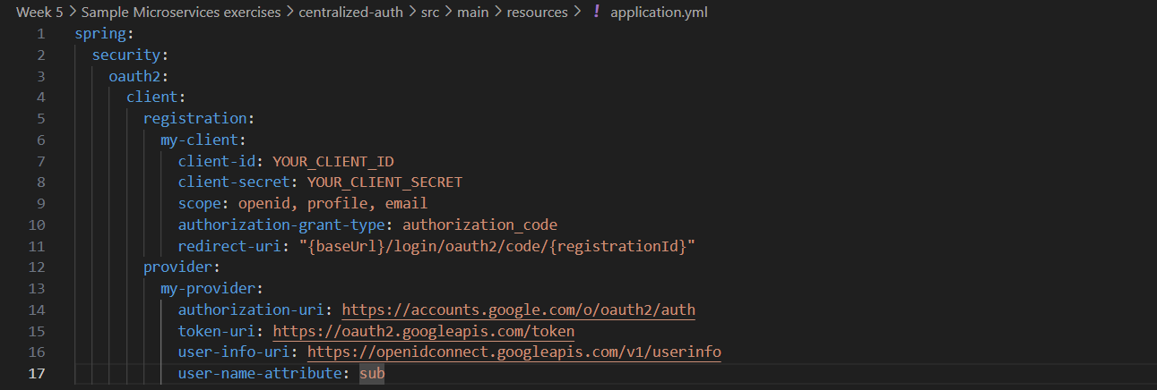application.yml

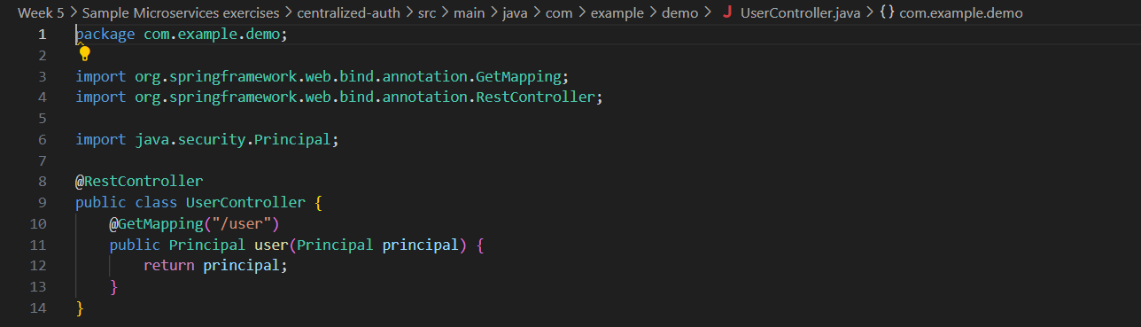UserController.java

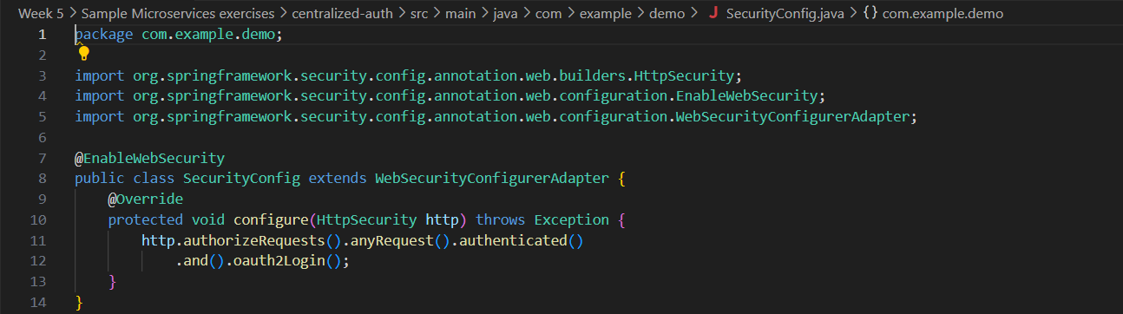SecurityConfig.java